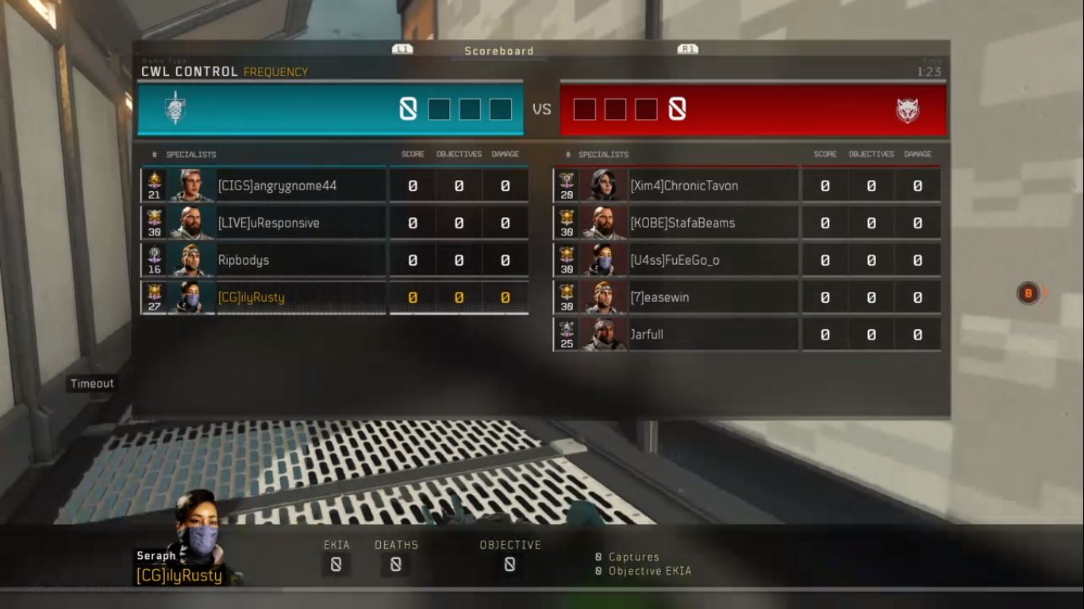

Scoreboard

RI

CWL CONTROL FREQUENCY

1:23

8000 v 0008

# SPECIALISTS

SCORE

OBJECTIVES DAMAGE

#

SPECIALISTS

SCORE

OBJECTIVES

DAMAGE

[CIGS]angrygnome44

0

0

21

0

[Xim4]ChronicTavon [KOBE]StafaBeams KOBEJSta

[LIVE]uResponsive

Ripbodys

[U4ss]FuEeGo_o

[CG]ilyRusty

[7]eas [7]easewin

Jarfull

Timeout

RE

En

SEHH

EKIA

DEATHS

OBJECTIVE

Seraph [CG]ilyRusty

8 Captures 8 Objective EKIA